Sun Game Server
J2ME Client API
Programmer's Guide
Copyright © 2006 Sun Microsystems, Inc., 4150 Network Circle, Santa Clara, California 95054, U.S.A. All rights reserved.
Sun Microsystems, Inc. has intellectual property rights relating to technology embodied in the product that is described in this document. In particular, and without limitation, these intellectual property rights may include one or more of the U.S. patents listed at http://www.sun.com/patents and one or more additional patents or pending patent applications in the U.S. and in other countries.
U.S. Government Rights - Commercial software. Government users are subject to the Sun Microsystems, Inc. standard license agreement and applicable provisions of the FAR and its supplements.
This distribution may include materials developed by third parties.
Sun, Sun Microsystems, the Sun logo and Java are trademarks or registered trademarks of Sun Microsystems, Inc. in the U.S. and other countries.
UNIX is a registered trademark in the U.S. and other countries, exclusivelyv licensed through X/Open Company, Ltd.
Products covered by and information contained in this service manual are controlled by U.S. Export Control laws and may be subject to the export or import laws in other countries. Nuclear, missile, chemical biological weapons or nuclear maritime end uses or end users, whether direct or indirect, are strictly prohibited. Export or reexport to countries subject to U.S. embargo or to entities identified on U.S. export exclusion lists, including, but not limited to, the denied persons and specially designated nationals lists is strictly prohibited.
DOCUMENTATION IS PROVIDED "AS IS" AND ALL EXPRESS OR IMPLIED CONDITIONS, REPRESENTATIONS AND WARRANTIES, INCLUDING ANY IMPLIED WARRANTY OF MERCHANTABILITY, FITNESS FOR A PARTICULAR PURPOSE OR NON-INFRINGEMENT, ARE DISCLAIMED, EXCEPT TO THE EXTENT THAT SUCH DISCLAIMERS ARE HELD TO BE LEGALLY INVALID.

Copyright © 2006 Sun Microsystems, Inc., 4150 Network Circle, Santa Clara, California 95054, Etats-Unis. Tous droits réservés.
Sun Microsystems, Inc. détient les droits de propriété intellectuels relatifs à la technologie incorporée dans le produit qui est décrit dans ce document. En particulier, et ce sans limitation, ces droits de propriété intellectuelle peuvent inclure un ou plus des brevets américains listés à l'adresse http://www.sun.com/patents et un ou les brevets supplémentaires ou les applications de brevet en attente aux Etats - Unis et dans les autres pays.
Cette distribution peut comprendre des composants développés par des tierces parties.
Sun, Sun Microsystems, le logo Sun et Java sont des marques de fabrique ou des marques déposées de Sun Microsystems, Inc. aux Etats-Unis et dans d'autres pays.
UNIX est une marque déposée aux Etats-Unis et dans d'autres pays et licenciée exlusivement par X/Open Company, Ltd.
Les produits qui font l'objet de ce manuel d'entretien et les informations qu'il contient sont regis par la legislation americaine en matiere de controle des exportations et peuvent etre soumis au droit d'autres pays dans le domaine des exportations et importations. Les utilisations finales, ou utilisateurs finaux, pour des armes nucleaires, des missiles, des armes biologiques et chimiques ou du nucleaire maritime, directement ou indirectement, sont strictement interdites. Les exportations ou reexportations vers des pays sous embargo des Etats-Unis, ou vers des entites figurant sur les listes d'exclusion d'exportation americaines, y compris, mais de maniere non exclusive, la liste de personnes qui font objet d'un ordre de ne pas participer, d'une facon directe ou indirecte, aux exportations des produits ou des services qui sont regi par la legislation americaine en matiere de controle des exportations et la liste de ressortissants specifiquement designes, sont rigoureusement interdites.
LA DOCUMENTATION EST FOURNIE "EN L'ETAT" ET TOUTES AUTRES CONDITIONS, DECLARATIONS ET GARANTIES EXPRESSES OU TACITES SONT FORMELLEMENT EXCLUES, DANS LA MESURE AUTORISEE PAR LA LOI APPLICABLE, Y COMPRIS NOTAMMENT TOUTE GARANTIE IMPLICITE RELATIVE A LA QUALITE MARCHANDE, A L'APTITUDE A UNE UTILISATION PARTICULIERE OU A L'ABSENCE DE CONTREFACON.

Introduction to the Sun Game Server
The Sun Game Server (SGS) is a distributed software system built specifically for the needs of game developers. It is an efficient, scalable, reliable, and fault-tolerant architecture that simplifies the coding model for the game developer.
The SGS is a distributed system. Each host contains an SGS slice that consists of a single stack of software running in a single process space. Each slice can handle 200-500 users, depending on the game and the hardware.
The figure below shows the architecture of the Sun Game Server:
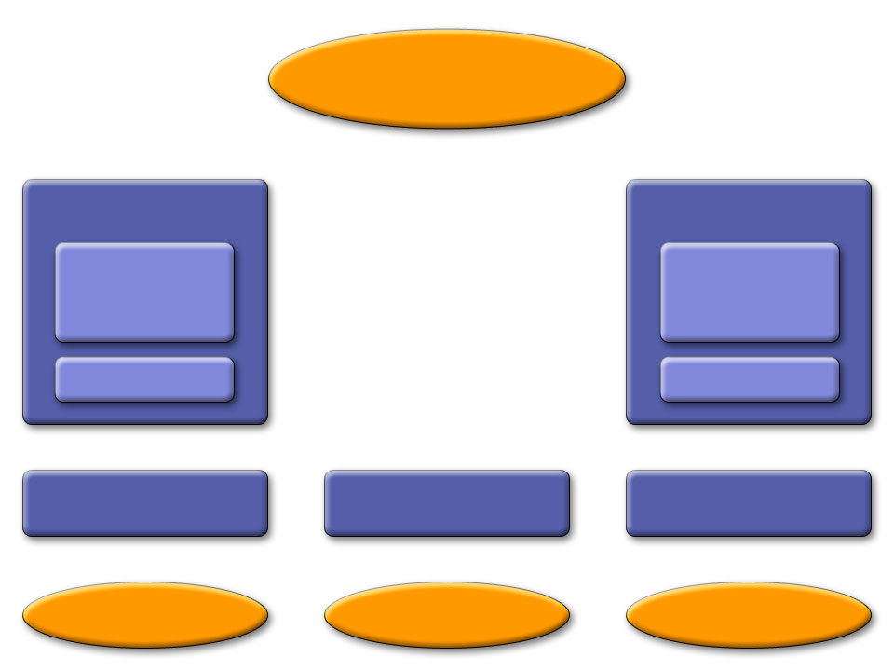
This architecture consists of four tiers.
Object Store
C Client
C Client API
J2SE Client
J2SE Client API
MIDP Client
MIDP Client API
Game Logic
Engine
Communications
Tier
Server Cluster
Game Logic
Engine
Communications
Tier
Server
Server
Server
The top tier (Tier 3) is a common data repository called the Object Store, which contains the entire game state and logic, implemented as a set of persistent Game Logic Objects (GLOs). Each SGS slice talks to this repository.
Tier 2, on the Servers, is the Game Logic Engine. The Game Logic Engine is a container that executes event-driven code provided by the game developer. This event handling code is farmed out across the slices such that the entire set of active Game Logic Engines looks to the developer like a single execution environment. Race conditions and deadlock avoidance are handled automatically by the system so the user can write their code as if it were a single-threaded system.
Tier 1, the communications tier, provides a highly efficient publish/subscribe channel system to the game clients. It also handles passing data from the clients up to the servers and from the servers back to the clients.
Tier 0 is the Client API. This is a code library that client applications (game clients) use to communicate with each other and with the communications tier. As part of the SGS SDK we make Tier 0 available for J2SE, J2ME, and C++ applications. The C++ code is portable C++ and has been ported by us to two targets—Win32 and the Sony Playstation Portable (PSP).
Tier 0 takes care of discovering and connecting to SGS servers, as well as handling fail-over to a new server should the one it is currently connected to suddenly fail.
For peer-to-peer communications, data passes only through Tier 0 and Tier 1.

More on the Communications Tier
The communications tier contains the following main sections:
- The Router does user authentication through pluggable Validators. Once a user has been authenticated, the Router provides a publish/subscribe channel mechanism to facilitate both peer-to-peer communications among clients and client/server communications with the Game Logic Engine. Validators are user-extensible (see the document Extending the SGS).
- The Discoverer collects information on available game connection points. (A connection point is a well-defined place where a client application can connect to a server application—for example, a particular user manager (discussed below) on a particular host.) The SGS back end makes this information available in the form of a regularly updated XML document that is accessible at a well-known URL. This document is the starting point for all client communications. From the XML document, the JMEDiscoverer extracts all the possible connection points for a given game, examines included parameters (such as the host and port), and chooses a connection point. Discoverers are also extensible. At the moment the JMEDiscoverer is the only one supported by the SGS back end for J2ME applications. In the future, however, other means of obtaining the discovery information may be provided.
- The User Manager encapsulates all knowledge of how a client connects to and communicates with the SGS. The user manager is defined by interfaces and encapsulate a particular manner of communication (protocol, connection type, and so on). The SGS software distribution provides a TCP/IP-based user manager implementation, suitable for J2SE and C++ clients, and an HTTP-based implementation for J2ME clients. The set of user managers is user-extensible (see the document Extending the SGS).
There is an API wrapper that the client side of the user manager plugs into. This API wrapper knows about protocols defined by the Router for user authentication and failover and how to use the Discoverer to obtain discovery information.
The SGS provides the following client-side APIs:
- J2SE
- J2ME (MIDP2.0)
- C++

This Document
This document focuses on the J2ME client API. It assumes that there is a server-side application with which the client communicates.

Overview of the J2ME Client API to the Sun Game Server
Note: Reference information on the classes discussed here is located in the J2ME API Javadocs directory.
The J2ME client interface to the Sun Game Server is an event/callback-based API. All server events are returned to the client as events/callbacks. This section goes through the major interfaces and events. The next section shows how a simple MIDlet implements the API.

The JMEClientManager and the JMEClientListenerInterface
A J2ME SGS client application is a remote program that communicates with the SGS back end to do interclient communication and to interface with SGS server applications. The client application communicates with the server application and with other clients through an instance of the JMEClientManager class. A single instance represents a single user of a single SGS server application. A client application can create a single JMEClientManager instance to log on to a single server application.
The client application performs outgoing communication (that is, login, data packets, and so on) by making calls on the JMEClientManager's API.
Incoming data is translated to events that are sent to the client application via a JMEClientListenerInterface. The client application must register an instance of the JMEClientListenerInterface (most likely itself) with the JMEClientManager.

The User Manager
The JMEClientManager talks to the server via a user manager. As discussed in the previous section, a game can have multiple user managers. Developers must determine which user manager their client application should use, based on its requirements. In the current SGS distribution, we provide only one user manager for J2ME applications, JMEHttpUserManagerClient. Others could be added in the future, or game developers could add their own. This is a connectionless, polling protocol. This means that client applications cannot assume a persistent connection to the server, and certain aspects of the API available in the J2SE version (e.g., reconnecting) are not available for J2ME clients.
A MIDlet that uses the SGS client library must specify the name of the user manager class it will be using by adding an attribute in its JAD file:
UsrMgrClassName: com.sun.gi.comm.users.client.impl.JMEHttpUserManagerClient
By default, JMEHttpUserManagerClient polls for events from the server, and sends client events to the server, every 500 milliseconds (that is, twice per second). This is configurable per game. Developers should be aware of polling frequency when designing client applications, since this will affect game performance.

Discovering Games
The client application must begin by finding its game and user manager on the server. As discussed in the previous section, this information is provided by a Discoverer. The one currently supported Discoverer for J2ME, JMEDiscoverer, gets this information from a discovery file.
A MIDlet that uses the SGS client library must specify the location of this file by adding an attribute in its JAD file. For example:
XML-Discovery-URL: http://localhost:8080/FakeDiscovery.xml

The Discovery File
The discovery file contains all the information the client needs to know to connect to one of the user managers in the available server applications. Here are sample contents of FakeDiscovery.xml, which is provided in this distribution for early client development. It contains entries for two games: ChatTest (which we discuss in the next section) and BattleBoard. There are two user managers for both ChatTest and BattleBoard.
<DISCOVERY>
-
<GAME id="1" name="ChatTest">
-
<USERMANAGER clientclass="com.sun.gi.comm.users.client.impl.TCPIPUserManagerClient">
<PARAMETER tag="host" value="127.0.0.1"/>
<PARAMETER tag="port" value="1150"/>
</USERMANAGER>
<USERMANAGER clientclass=”com.sun.gi.comm.users.client.impl.JMEHttpUserManagerClient”>
<PARAMETER tag="host" value="127.0.0.1"/>
<PARAMETER tag=”port” value=”8080”/>
<PARAMETER tag=”pollinterval” value=”500”/>
</USERMANAGER>
</GAME>
-
<GAME id="5" name="BattleBoard">
-
<USERMANAGER clientclass="com.sun.gi.comm.users.client.impl.TCPIPUserManagerClient">
<PARAMETER tag="host" value="127.0.0.1"/>
<PARAMETER tag="port" value="1180"/>
</USERMANAGER>
<USERMANAGER clientclass=”com.sun.gi.comm.users.client.impl.JMEHttpUserManagerClient”>
<PARAMETER tag="host" value="127.0.0.1"/>
<PARAMETER tag=”port” value=”8080”/>
<PARAMETER tag=”pollinterval” value=”500”/>
</USERMANAGER>
</GAME>
</DISCOVERY>
Note these points about the file:
- TCPIPUserManagerClient would be used for J2SE and C++ clients, J2MEHttpUserManagerClient would be used for J2ME clients only.
- JMEHttpUserManagerClient has a pollinterval parameter, because it is a polling protocol. TCPIPUserManagerClient doesn't require this parameter.
- All user managers for both games use the same host. In a production environment, of course, there would be multiple hosts. These would appear in other <USERMANAGER> blocks in the same discovery file.
- TCPIPUserManagerClient uses different ports on the host for different games. All communication for ChatTest goes through port 1150, and all communication for BattleBoard goes through port 1180.
- JMEHttpUserManagerClient uses the same port, 8080, for both games. This is because the HTTPUserManagers for different games all share a single “web browser” handling all HTTP communications for all games on a host. It listens on a single port, and the HTTP traffic for all games must arrive on that port.
A static local file such as FakeDiscovery.xml is useful when testing an application. In a production environment, however, the client application would point to a web server to get a dynamically generated discovery file. The URL of this web server would be provided by the SGS host.

Parsing the Discovery Document
Client applications should use the JMEDiscoverer class provided in the API to parse the discovery document and return games, user managers, and parameters found in the document. Currently, XML-based discovery from a known URL is the only discovery strategy provided; however, the API is pluggable so that other strategies could be developed for different network architectures.

Connecting and Logging in to the Server
As noted above, the current J2ME API includes only one user manager, JMEHttpUserManagerClient. Since this is a connectionless, polling protocol, “connecting” is equivalent to logging in to the server.
A client begins by requesting a list of the kinds of connection points (the user manager client class) available for their game from the JMEClientManager. The JMEClientManager gets this information from the Discoverer and returns it to the client.
The client compares that list with its own preferences and selects one user manager client class name and requests the JMEClient Manager to connect to a User Manager of that type.
When the JMEClientManager connects to a game, it requests the connection points for the game that match the chosen User Manager type from the Discoverer. It then asks the UserManagerPolicy to choose one.
Once the JMEClientManager has a communication connection point, it creates an instance of the UserManagerClient class specified by that connection point and passes it the list of initialization parameter tuples that are also defined by the connection point. It then asks the new UserManagerClient to complete the connection.

Validation
The JMEClientManager starts the login process by sending a login request to the user manager.
A game typically requires validation in order to accept a connection from an instance of its UserManagerClient class.The user manager responds to a login request by returning an array of Calllback objects to the client application through one or more validationDataRequest messages that are delivered to the JMEClientListenerInterface object.
A JMEClientListener object responds to this event by calling the JMEClientManager method sendValidationResponse with the appropriately filled-in callbacks.
This process continues until either the response is rejected by the user manager (in which case the listener receives a connectionRejected message containing a string giving the reason for refusal), or all responses have been accepted, in which case the listener receives a connectionAccepted message containing the assigned userID for this connection.
It is possible that more than one validationRequest callback may occur. A client application should be written so that it can handle any number of these callbacks. The sequence of validationRequest callbacks for any given connection attempt will be terminated by either the connectionAccepted or connectionRejected callback.
Validation is entirely optional and specified at server-side game-install time. In the trivial case where the server doesn't require validation, the validation process is skipped and the listener immediately receives the connectionAccepted message.
See the discussion of the sample client, JMEChatClient, for an example of how validation works.

Logoff
A client application requests that a JMEClientManager disconnect from the server by calling the disconnect method on the JMEClientManager's API. At this point it stops polling and will receive no more messages from the server. Other clients connected to the game receive a message that the user logged out, as described below.

Game Events
While the JMEClientManager is connected to the SGS back end, it can report the following events to its listener, JMEClientListenerInterface:
- dataReceived
This listener method gets called whenever an inbound data packet arrives that was sent to a channel to which this user subscribes. See below for a discussion of channels.
- userLoggedIn
This method gets called once for every JMEClientManager (that is, every user) that is connected to the game that this JMEClientManager joined. It then gets called periodically as new users join the game.
- userLoggedOut
This method gets called when any JMEClientManager whose connection was reported by userLoggedIn logs off.
The JMEClientManager sends a message to the server via the sendServerMessage method.

Channels
In addition to client-to-server communications, the client API makes a publish/subscribe channel system available to the client application. Client-to-client and server-to-client communications always happen via a channel. Channels are scoped within a single server application, so that only that server application and the clients logged in to it may communicate with each other over a channel.
The JMEClientManager defines SGS channels for use by a client application, and the JMEClientListenerInterface defines how channel events are reported back to the client.
Clients can send messages to a specific user of the channel, multicast messages to multiple users, and broadcast messages to all users of the channel. In addition, the user receives userJoinedChannel and userLeftChannel messages when other users join or leave a channel.
As discussed in the first section, messages sent between clients only go up through Tier 1 (the Communications Tier) of the SGS architecture. They are not processed by the Game Logic Engine. (There is one exception,which is when the server application specifically requests to “eavesdrop” on one or more players on one or more channels. In that case the eavesdropping data is propagated up to the Game Logic Engine. See the SGS Server Application Developer's Guide for more information on this feature.)

What a J2ME Client Application Needs to Do
A J2ME SGS client application at a minimum needs to do the following to interact with the server:
- Implement the JMEClientListenerInterface so that it can receive events from the server.
- Create a Discoverer to find the discovery information. In practice today this means instancing the JMEDiscoverer and giving it the URL location of an XML discovery file.
- Create a UserManagerPolicy to help the JMEClientManager decide which of the various possible connection points to user. Currently the API provides one UserManagerPolicy, the DefaultUserManagerPolicy.
- Request a list of the types of connections available for the game we wish to log in to.
- Connect to a connection point of the chosen type. Handle authentication callbacks as requested.
- Create and manage channels by which users can communicate with each other.
- Sending data and respond to data that is received.
- Provide a means of logging off from the server application.
The following section walks through a very simple client application, JMEChatClient, that does these things.

The JMEChatClient Example Client
The example program ChatTest is a basic chat program implemented using the Sun Game Server and provided with the SGS distribution. It allows users to log in to the game, send messages to the server and to each other over a DCC (Direct Client to Client) channel, and choose other channels over which to send and receive messages.
JMEChatClient is a J2ME MIDlet for this server application. It shows, in simplified fashion, how to use the SGS J2ME client API. In summary:
- It uses the JMEDiscoverer constructor to parse the discovery file and provide discovery information back to the rest of the API
- It uses the JMEDiscoverer class to discover the available games and their user managers.
- It calls methods in the JMEClientManager class to communicate with the user manager (for example, to log into and out of the game, to set up channels, and to send messages to the server and to other game users).
- It implements the JMEClientListenerInterface to receive events and messages from the server. These are sent to the client by the user manager via the JMEClientManager.
- It uses various utilities provided in the API (for example, NameCallback and PasswordCallback) to handle name and password callbacks.
Source code for JMEChatClient is included in the appendix.
In our discussion of JMEChatClient, we focus on the interactions with the server via the API; we assume the reader is familiar with the details of Java programming and, in particular, with programming a J2ME user interface.

Command Actions
This code in JMEChatClient shows the methods called in response to various user actions on the displayable. Following sections will go into more detail about these methods.
public void commandAction(Command command, Displayable displayable) {
if (displayable == loginForm) {
if (command == exitCommand) {
doLogout();
exitMIDlet();
} else if (command == loginCommand) {
initializeClientManager();
}
} else if (displayable == postLoginForm) {
if (command == channelOk) {
clientMgr.openChannel(channelNameField.getString());
} else if (command == logoutCommand) {
doLogout();
getDisplay().setCurrent(loginForm);
} else if (command == sendCommand) {
sendMessageToUser();
} else if (command == channelSend) {
sendChannelMessage();
} else if (command == serverMessage) {
sendServerMessage();
}
}
}

Logging in to the Server Application
As discussed above, a client must begin by connecting to the server application. Since JMEChatClient is using a connectionless, polling protocol (JMEHttpUserManagerClient), this is equivalent to logging in to the server.

Launching the Application
This process begins when the user presses Launch to launch JMEChatClient, as shown below.
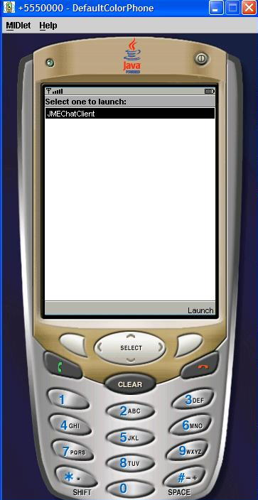

Logging In
JMEChatClient then displays the login screen, as shown below.
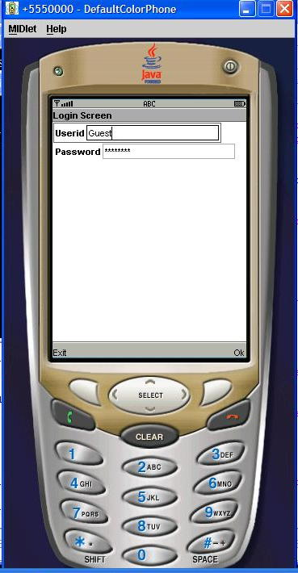

Finding the Game
When the user enters the Userid and Password and presses Ok, JMEChatClient executes the initializeClientManager method to start an instance of JMEClientManager for this user and begin the process of game discovery:
private void initializeClientManager() {
clientMgr = new JMEClientManager("ChatTest",
new JMEDiscoverer(this.getAppProperty("XML-Discovery-URL")),
this.getAppProperty("UsrMgrClassName"));
clientMgr.setListener(this);
clientMgr.discoverGames();
JMEChatClient communicates with the server application via the JMEClientManager interface. It needs to tell JMEClientManager the name of the server application and how to find it. So it passes the following:
- The name of the server application, ChatTest.
- A JMEDiscoverer that is set to parse the local discovery file (whose location is specified by the attribute XML-Discovery-URL) that lists all available games and the user managers for them. JMEDiscoverer parses the file to determine if ChatTest is there and, if so, what User Managers are supported at what connection points.
- The user manager to use with the game; its class is specifed by the attribute UsrMgrClassName.
The actual values of XML-Discovery-URL and UsrMgrClassName are specified as attributes in the JAD file for the MIDlet, as mentioned in the previous section. Here are the contents of the JMEChatClient JAD file:
MIDlet-1: JMEChatClient, , com.sun.gi.apps.commtest.client.JMEChatClient
MIDlet-Jar-Size: 42804
MIDlet-Jar-URL: JMEChatClient.jar
MIDlet-Name: JMEChatClient
MIDlet-Vendor: Vendor
MIDlet-Version: 1.0
MicroEdition-Configuration: CLDC-1.1
MicroEdition-Profile: MIDP-2.0
UsrMgrClassName: com.sun.gi.comm.users.client.impl.JMEHttpUserManagerClient
XML-Discovery-URL: http://localhost:8080/FakeDiscovery.xml
See the previous section for sample contents of the FakeDiscovery.xml document.
As part of establishing the connection, JMEChatClient uses the setListener method from JMEClientManager to establish itself as the listener for events that the server sends to JMEClientListenerInterface via JMEClientManager.
Finally, it uses the JMEClientManager method discoverGames to determine if any of the discovered games is ChatTest.
JMEChatClient uses the callback discoveredGames from JMEClientListenerInterface to find out if JMEDiscoverer was able to find the ChatTest game. If so, it uses the JMEClientManager method connect to connect to the game:
public void discoveredGames() {
try {
clientMgr.connect();
} catch (Exception ex) {
ex.printStackTrace();
}
}

Specifying User Name and Password
The validation strategy is up to the server application; ChatTest requires a name and password. The user manager informs the JMEClientListenerInterface via the validationDataRequest callback that it needs validation information.
JMEChatClient uses the API utilities NameCallback and PasswordCallback to package up the login information provided by the user:
private void dealWithCallbacks(Callback[] callbacks) {
//for now hard code dealing with the login callback
NameCallback nm = (NameCallback)callbacks[0];
nm.setName(userNameField.getString());
PasswordCallback pb = (PasswordCallback)callbacks[1];
pb.setPassword(passwordField.getString().toCharArray());
}
JMEChatClient sends this information to to the server application via the JMEClientManager method sendValidationResponse, sent in response to the validationDataRequest callback:
public void validationDataRequest(Callback[] callbacks) {
dealWithCallbacks(callbacks);
try {
clientMgr.sendValidationResponse(callbacks);
} catch (UnsupportedCallbackException ex) {
exceptionOccurred(ex);
}
}
JMEChatClient uses the API class UnsupportedCallbackException to handle the case in which it doesn't recognize the callback from the server. This causes it to call the exceptionOccurred method to display a message on the displayable:
public void exceptionOccurred(Exception ex) {
Displayable newScreen = changeState(EXCEPTION_OCCURRED);
getDisplay().setCurrent(getGenericAlert("Exception occurred " + ex.getMessage()), newScreen);
}

If the Login Is Accepted
If the server accepts the login, it returns a userID for this user via the loginAccepted callback in the JMEClientListenerInterface:
public void loginAccepted(byte[] userID) {
clientMgr.openChannel(DCC_CHAN_NAME);
Displayable newScreen = changeState(LOGON);
myUserIDItem.setText(StringUtils.bytesToHex(userID));
getDisplay().setCurrent(getGenericAlert("Login Successful for " + StringUtils.bytesToHex(userID)), newScreen);
}
Note that, as part of loginAccepted, JMEChatClient calls the JMEClientManager method openChannel to open DCC_CHAN_NAME. This opens a DCC (Direct Client-to-Client) channel for communication between users. A user can also open other channels, as described in the next section.
JMEChatClient also displays a new screen, showing the user's userID for the game, as shown below.
Note that user IDs are really session IDs in that they change from login to login. They stay the same during failover, however.
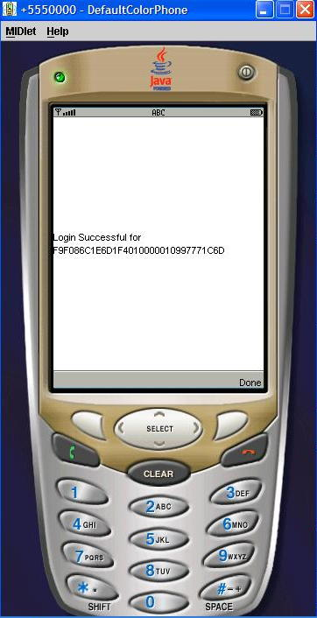

If the Login Is Rejected
If the login is rejected, the server sends a loginRejected event to the JMEClientListernerInterface, along with a message explaining the rejection. JMEChatClient updates the user interface accordingly:
public void loginRejected(String message) {
Displayable newScreen = changeState(LOGON_REJECT);
getDisplay().setCurrent(getGenericAlert(message), newScreen);
}

After Login
When the user presses Done after receiving the successful login message, JMEChatClient displays the post-login form. Pressing Menu from this screen displays a menu that offers three choices:
- OpenChannel – This opens a channel for communication with other users.
- Send message – This lets the user send a message to one or more other users.
- Server Message – This lets the user send a message to the server.
See the figure below.
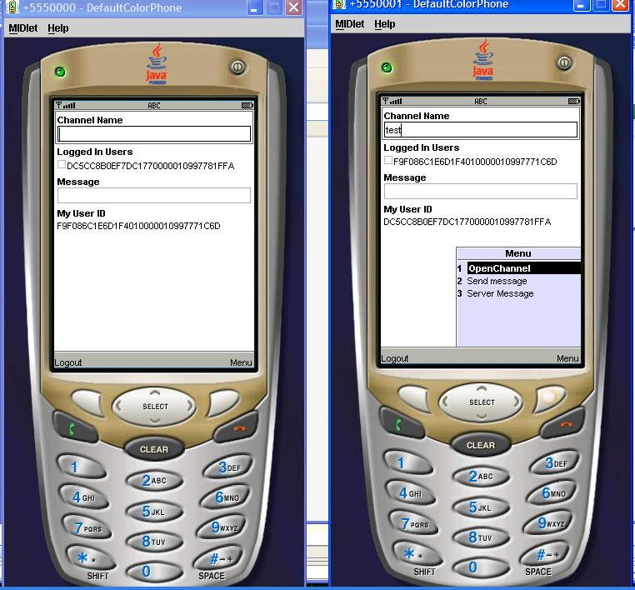

Displaying Users

Another User Logs in to the Game
When a user first logs in to ChatTest, the server sends userLoggedIn callbacks to JMEClientListenerInterface for every other user currently logged in to the game. JMEChatClient then adds the userIDs of each of these users to the list on the screen. As other users join, additional callbacks are issued for them.
Here is the code that handles this in JMEChatClient:
public void userLoggedIn(byte[] userID) {
String userName = StringUtils.bytesToHex(userID);
users.put(userName,userID);
usersList.append(userName,null);
Displayable newScreen = changeState(USER_LOGGED_IN);
getDisplay().setCurrent(getGenericAlert("User added " + userName), newScreen);
}

A User Logs out of the Game
If a user leaves the game, the server sends an event to the userLoggedOut callback in JMEClientListenerInterface. In response, JMEChatClient removes this user's userID from the list on the screen:
public void userLoggedOut(byte[] userID) {
Displayable newScreen = changeState(USER_LOGGED_OUT);
usersList.deleteAll();
String userName = StringUtils.bytesToHex(userID);
users.remove(userName);
Enumeration userIds = users.keys();
while (userIds.hasMoreElements()) {
usersList.append((String) userIds.nextElement(), null);
}
getDisplay().setCurrent(getGenericAlert("User dropped " + StringUtils.bytesToHex(userID)), newScreen);
}

Opening a Channel
There are two kinds of channels in ChatTest: the DCC (Direct Client-to-Client) channel and user-specified channels.
The DCC channel is defined by the application. It is used for sending messages to individual users or groups of users, and it was opened when the user's login was accepted, as discussed above.
User-specified channels can have any name. They can be used to send messages to any other users who have joined the same channel. In ChatTest, a user can open a channel by choosing 1 from the menu.
This code in JMEChatClient's commandAction method invokes the openChannel method from JMEClientManager to open the channel that the user specified:
if (command == channelOk) {
clientMgr.openChannel(channelNameField.getString());
The server sends a joinedChannel event to JMEClientListenerInterface to confirm that the user has joined the specified channel. In response, JMEChatClient updates the screen and displays a “Connected to Channel” message:
public void joinedChannel(String name, byte[] channelID) {
if (name.equals(DCC_CHAN_NAME)) {
dccChannelId = channelID;
} else {
channels.put(name,channelID);
Displayable newScreen = changeState(JOINED_CHAN);
channelList.append(name,null);
getDisplay().setCurrent(getGenericAlert("Connected to Channel " + name), newScreen);
this.channelID = channelID;
}
}
Once a user has joined a channel, the server sends events concerning that channel to this client instance.

Another User Joins an Open Channel
When a user first opens a channel, the server sends an event to the JMEClientListenerInterface callback userJoinedChannel for every other user who currently has that channel open. In response, JMEChatClient displays a message and adds the userID of each of these users to the list on the screen. As other users join, additional callbacks are issued for them.
Here is the code in JMEChatClient:
public void userJoinedChannel(byte[] channelID, byte[] userID) {
Displayable newScreen = changeState(USER_JOINED_CHAN);
getDisplay().setCurrent(getGenericAlert("User joined channel " + StringUtils.bytesToHex(userID) + " channel " + StringUtils.bytesToHex(channelID)), newScreen);

}
And here is the screen display:
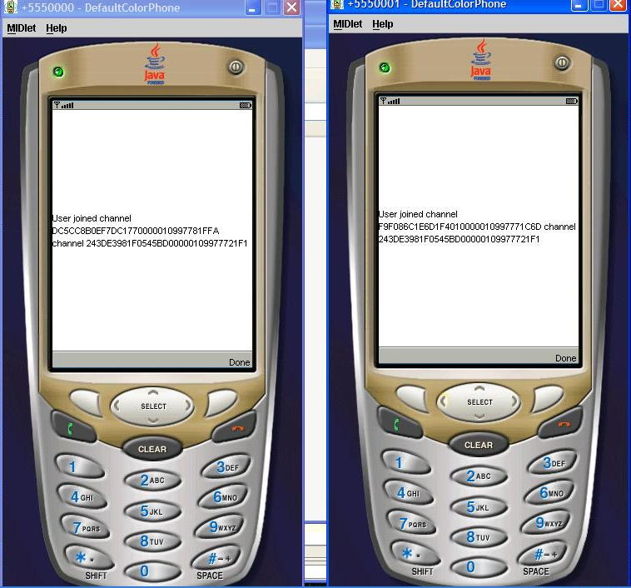

Another User Leaves an Open Channel
If another user leaves a channel that this user has open, the server sends an event to the JMEClientListenerInterface callback userLeftChannel. JMEChatClient displays a message and removes this user's userID from the list on the screen:
public void userLeftChannel(byte[] channelID, byte[] userID) {
Displayable newScreen = changeState(USER_LEFT_CHAN);
getDisplay().setCurrent(getGenericAlert("User left channel " + StringUtils.bytesToHex(userID) + " channel " + StringUtils.bytesToHex(channelID)), newScreen);

}

This User Leaves an Open Channel
If the server removes this user from a channel, it sends an event to the JMEClientListenerInterface callback leftChannel. JMEChatClient displays a message and updates the screen:
public void leftChannel(byte[] channelID) {
Displayable newScreen = changeState(JOINED_CHAN);
getDisplay().setCurrent(getGenericAlert("Left channel "+ StringUtils.bytesToHex(channelID)), newScreen);
}

Sending and Receiving Messages
As discussed above, JMEChatClient provides ways of sending messages to and receiving messages from the server and other users.

Sending a Message to the Server
In the JMEChatClient application, the user sends a message to the server application by typing the message in the message field and choosing 3 from the menu. JMEChatClient then calls the JMEClientManager method SendServerMessage to send the message to the server application:
private void sendServerMessage() {
String dataString = messageField.getString();
ByteBuffer data = ByteBuffer.wrap(dataString.getBytes());
clientMgr.sendServerMessage(data);
messageField.setString("");
}
In ChatTest, the server simply prints the message sent to it. The functionality is included in this program to show how a client application would send data to the server.

Sending a Message to Specific Users
If the user types a message in the message field and chooses 2 from the menu, the message will be sent to one or more users, or to all users of a channel. Messages for specific users are sent over the special DCC channel. The user selects the users by choosing their checkboxes on the screen.
JMEChatClient calls the sendMessageToUser method to determine how many users have been selected. If there is a single user, this method calls the JMEClientManager method sendUnicastData. If there are multiple users, it calls the method sendMulticastData.
private void sendMessageToUser() {
boolean [] selected = new boolean[users.size()];
usersList.getSelectedFlags(selected);
Vector selectedUsers = new Vector();
for (int i = 0;i < selected.length;i++) {
if (selected[i]) {
selectedUsers.addElement(usersList.getString(i));
}
}
if (selectedUsers.size() == 1) {
String message = messageField.getString();
//byte[] user = getSelectedUser((String) selectedUsers.firstElement());
byte[] user = (byte[]) users.get(selectedUsers.firstElement());
clientMgr.sendUnicastMsg(dccChannelId,user, ByteBuffer.wrap(message.getBytes()));
} else if (selectedUsers.size() > 1) {
byte[][] targetList = getSelectedUsers(selectedUsers);
clientMgr.sendMulticastData(dccChannelId,targetList,ByteBuffer.wrap(messageField.getString().getBytes()));
}
messageField.setString("");
}

Sending a Message to All Users of a Channel
If the message is to go to all users of a channel, JMEChatClient calls the method sendChannelMessage to get the text of the message field and the name of the channel from the user input. The method then calls the JMEClientManager method sendBroadcastMessage to actually send the data on the specified channel. Here is the code from JMEChatClient:
private void sendChannelMessage() {
String dataString = messageField.getString();
String channelName = channelList.getString(channelList.getSelectedIndex());
ByteBuffer data = ByteBuffer.wrap(dataString.getBytes());
clientMgr.sendBroadcastMessage((byte[]) channels.get(channelName), data);
messageField.setString("");
}

Receiving Data
When data is received for this user, the server informs JMEClientListenerInterface via the dataReceived callback, specifying the channel it arrived on, the userID of the user who sent it, and the data itself. In response, JMEChatClient updates the screen and displays the data.
Here is the code:
public void dataReceived(byte[] chanID, byte[] from, ByteBuffer data) {
Displayable newScreen = changeState(USER_LEFT_CHAN);
byte[] textb = new byte[data.remaining()];
data.get(textb);
getDisplay().setCurrent(getGenericAlert("Message from " + StringUtils.bytesToHex(chanID) + " : " + new String(textb)), newScreen);
}
The screenshot below shows the message “channel message” arriving on a channel:
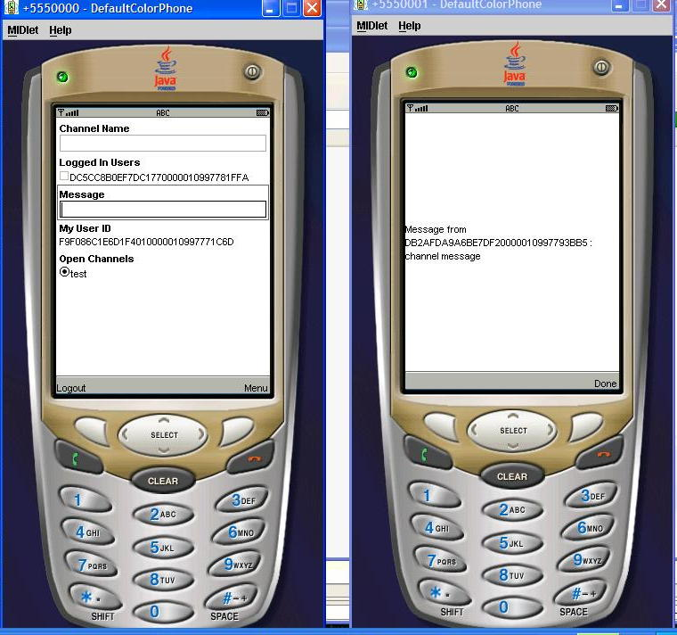

Logging Out
When the user presses Logout, JMEChatClient calls the doLogout method. This method calls the JavaClientManager method disconnect to log out from the server. (Since we are using a connectionless protocol, logging out is equivalent to disconnecting.) Here is doLogout:
private void doLogout() {
clientMgr.disconnect();
users.clear();
createPostLogonScreen();
channels = new Hashtable();
currentState = LOGGED_OUT;
}
When the user has logged out, JMEChatClient can exit the MIDlet:
public void exitMIDlet() {
getDisplay().setCurrent(null);
destroyApp(true);
notifyDestroyed();
}

Appendix: Source Code for JMEChatClient

/*
* JMEChatClient.java
*
* Created on February 14, 2006, 8:25 AM
*/

package com.sun.gi.apps.commtest.client;

import com.sun.gi.comm.users.client.JMEClientListenerInterface;
import com.sun.gi.comm.users.client.impl.JMEJMEClientManager;
import com.sun.gi.comm.discovery.impl.JMEDiscoverer;
import com.sun.gi.utils.jme.ByteBuffer;
import com.sun.gi.utils.jme.Callback;
import com.sun.gi.utils.jme.NameCallback;
import com.sun.gi.utils.jme.PasswordCallback;
import com.sun.gi.utils.jme.StringUtils;
import com.sun.gi.utils.jme.UnsupportedCallbackException;
import java.util.Enumeration;
import java.util.Hashtable;
import java.util.Vector;
import javax.microedition.midlet.*;
import javax.microedition.lcdui.*;

/**
*
* @author as93050
*/
public class JMEChatClient extends MIDlet implements CommandListener, JMEClientListenerInterface {

private JMEJMEClientManager clientMgr;
private Command logoutCommand;
private Form loginForm;
private Command exitCommand;
private TextField userNameField;
private TextField passwordField;
private Command loginCommand;
private Form postLoginForm;
private TextField channelNameField;
private StringItem myUserIDItem;
private Command channelOk;
private Command channelSend;
private Command serverMessage;
private Hashtable users;
private Hashtable channels;
private Alert genericAlert;
private Command sendCommand;
private Displayable shouldBeCurrent;
private ChoiceGroup usersList;
private TextField messageField;
private ChoiceGroup channelList;

private byte[] channelID;
private String userid;
private static String DCC_CHAN_NAME = "__DCC_Chan";
private byte[] dccChannelId;
private int currentState = LOGGED_OUT;

private final static int LOGGED_OUT = 0;
private final static int LOGGED_IN = 1;
private final static int OPENED_CHANNEL = 2;

private final static int LOGON = 0;
private final static int LOGON_REJECT = 1;
private final static int CHANNEL_OPENED = 2;
private final static int SENT_MESSAGE = 3;
private final static int LOGOUT = 4;
private final static int USER_LOGGED_IN = 5;
private final static int USER_LOGGED_OUT = 6;
private final static int USER_JOINED_CHAN = 7;
private final static int USER_LEFT_CHAN = 8;
private final static int JOINED_CHAN = 9;
private final static int EXCEPTION_OCCURRED = 10;
private final static int START_APP = 11;

/** Creates a new instance of HelloMidlet */
public JMEChatClient() {
users = new Hashtable();
channels = new Hashtable();
}

/** This method initializes UI of the application.
*/
private void initialize() {
createGuiComponents();
getDisplay().setCurrent(changeState(START_APP));
shouldBeCurrent = getDisplay().getCurrent();
}

/** Called by the system to indicate that a command has been invoked on a particular displayable.
* @param command the Command that ws invoked
* @param displayable the Displayable on which the command was invoked
*/
public void commandAction(Command command, Displayable displayable) {
if (displayable == loginForm) {
if (command == exitCommand) {
doLogout();
exitMIDlet();
} else if (command == loginCommand) {
initializeJMEClientManager();
}
} else if (displayable == postLoginForm) {
if (command == channelOk) {
clientMgr.openChannel(channelNameField.getString());
} else if (command == logoutCommand) {
doLogout();
getDisplay().setCurrent(loginForm);
} else if (command == sendCommand) {
sendMessageToUser();
} else if (command == channelSend) {
sendChannelMessage();
} else if (command == serverMessage) {
sendServerMessage();
}
}
}

/**
* This method should return an instance of the display.
*/
public Display getDisplay() {
return Display.getDisplay(this);
}

private void createGuiComponents() {
createLoginForm();
createPostLogonScreen();

}
/**
* This method should exit the midlet.
*/
public void exitMIDlet() {
getDisplay().setCurrent(null);
destroyApp(true);
notifyDestroyed();
}

/** This method returns instance for LoginForm component and should be called instead of accessing LoginForm field directly.
* @return Instance for LoginForm component
*/
public void createLoginForm() {
createLoginFormComponents();
loginForm = new Form("Login Screen", new Item[] {
userNameField,
passwordField
});
loginForm.addCommand(exitCommand);
loginForm.addCommand(loginCommand);
loginForm.setCommandListener(this);
}

private void createLoginFormComponents() {
exitCommand = new Command("Exit", Command.EXIT, 1);
userNameField = new TextField("Userid", "Ari", 16, TextField.ANY);
passwordField = new TextField("Password", "password", 16, TextField.PASSWORD);
loginCommand = new Command("Ok", Command.OK, 1);
}

private void createPostLogonScreen() {
createPostLogonComponents();
postLoginForm = new Form(null, new Item[] {channelNameField,
usersList,messageField,myUserIDItem});
postLoginForm.addCommand(channelOk);
postLoginForm.addCommand(sendCommand);
postLoginForm.addCommand(logoutCommand);
postLoginForm.addCommand(serverMessage);
postLoginForm.setCommandListener(this);
}

private void createPostLogonComponents() {
channelNameField = new TextField("Channel Name", null, 120, TextField.ANY);
usersList = new ChoiceGroup("Logged In Users",ChoiceGroup.MULTIPLE);
messageField = new TextField("Message", "", 120, TextField.ANY);
channelOk = new Command("OpenChannel", Command.OK, 1);
sendCommand = new Command("Send message", Command.OK, 2);
logoutCommand = new Command("Logout",Command.CANCEL,2);
channelSend = new Command("Send to Channel", Command.OK, 1);
serverMessage = new Command("Server Message", Command.OK,3);
channelList = new ChoiceGroup("Open Channels",ChoiceGroup.EXCLUSIVE);
usersList = new ChoiceGroup("Logged In Users",ChoiceGroup.MULTIPLE);
myUserIDItem = new StringItem("My User ID ","");
}

private void updatePostLoginScreen() {
postLoginForm.addCommand(channelSend);
postLoginForm.append(channelList);
}

private Alert getGenericAlert(String alertText) {
if (genericAlert == null) {
genericAlert = new Alert(null, alertText, null, AlertType.INFO);
genericAlert.setTimeout(-2);
} else {
genericAlert.setString(alertText);
}
return genericAlert;
}

private Displayable changeState(int event) {
Displayable newScreen = shouldBeCurrent;
switch (currentState) {
case LOGGED_OUT:
if (event == LOGON) {
currentState = LOGGED_IN;
newScreen = postLoginForm;
shouldBeCurrent = newScreen;
} else if (event == LOGON_REJECT) {
newScreen = loginForm;
shouldBeCurrent = newScreen;
} else if (event == START_APP) {
newScreen = loginForm;
shouldBeCurrent = newScreen;
}
break;
case LOGGED_IN:
if (event == LOGOUT) {
currentState = LOGGED_OUT;
newScreen = loginForm;
shouldBeCurrent = newScreen;
} else if (event == JOINED_CHAN) {
currentState = CHANNEL_OPENED;
updatePostLoginScreen();
newScreen = postLoginForm;
shouldBeCurrent = newScreen;
} else if (event == START_APP) {
newScreen = postLoginForm;
shouldBeCurrent = newScreen;
}
case OPENED_CHANNEL:
if (event == START_APP) {
currentState = CHANNEL_OPENED;
updatePostLoginScreen();
newScreen = postLoginForm;
shouldBeCurrent = newScreen;
}
default:

}
return newScreen;
}

public void startApp() {
initialize();
}

public void pauseApp() {
clientMgr.stopPolling();
}

public void destroyApp(boolean unconditional) {
}

/**
* This event informs us that further information is
* needed in order to validate the user.
* @param cbs An array of Callback structures to be filled out and sent back.
*/
public void validationDataRequest(Callback[] callbacks) {
dealWithCallbacks(callbacks);
try {
clientMgr.sendValidationResponse(callbacks);
} catch (UnsupportedCallbackException ex) {
exceptionOccurred(ex);
}
}

/**
* This event informs us that the user has successfully logged in
*
* @param userID An ID issued to represent this user.
* <b>UserIDs are not guaranteed to remain the same between logons.</b>
*/
public void loginAccepted(byte[] userID) {
clientMgr.openChannel(DCC_CHAN_NAME);
Displayable newScreen = changeState(LOGON);
myUserIDItem.setText(StringUtils.bytesToHex(userID));
getDisplay().setCurrent(getGenericAlert("Login Successful for " + StringUtils.bytesToHex(userID)), newScreen);
}

/**
* This event informs us that user validation has failed.
* @param message A string containing an explaination of the failure.
*/
public void loginRejected(String message) {
Displayable newScreen = changeState(LOGON_REJECT);
getDisplay().setCurrent(getGenericAlert(message), newScreen);
}

/**
* This event informs us about other users of the game.
* When logon first succeeds there will be one of these callabcks sent for every currently
* logged-in user of this game. As other users join, additional callabcks will be issued for them.
* @param userID The ID of the other user
*/
public void userLoggedIn(byte[] userID) {
String userName = StringUtils.bytesToHex(userID);
users.put(userName,userID);
usersList.append(userName,null);
Displayable newScreen = changeState(USER_LOGGED_IN);
getDisplay().setCurrent(getGenericAlert("User added " + userName), newScreen);
}

/**
* This event informs us that a user has logged out of the game.
* @param userID The user that logged out.
*/
public void userLoggedOut(byte[] userID) {
Displayable newScreen = changeState(USER_LOGGED_OUT);
usersList.deleteAll();
String userName = StringUtils.bytesToHex(userID);
users.remove(userName);
Enumeration userIds = users.keys();
while (userIds.hasMoreElements()) {
usersList.append((String) userIds.nextElement(), null);
}
getDisplay().setCurrent(getGenericAlert("User dropped " + StringUtils.bytesToHex(userID)), newScreen);
}

/**
* This event informs us of the successful opening of a channel.
* @param channelID The ID of the newly joined channel
*/
public void joinedChannel(String name, byte[] channelID) {
if (name.equals(DCC_CHAN_NAME)) {
dccChannelId = channelID;
} else {
channels.put(name,channelID);
Displayable newScreen = changeState(JOINED_CHAN);
channelList.append(name,null);
getDisplay().setCurrent(getGenericAlert("Connected to Channel " + name), newScreen);
this.channelID = channelID;
}
}

/**
* This callback informs the user that they have left or been removed from a channel.
* @param channelID The ID of the channel left.
*/
public void leftChannel(byte[] channelID) {
Displayable newScreen = changeState(JOINED_CHAN);
getDisplay().setCurrent(getGenericAlert("Left channel "+ StringUtils.bytesToHex(channelID)), newScreen);
}

/**
* This method is called whenever a new user joins a channel that we have open.
* A set of these events are sent when we first join a channel-- one for each pre-existing
* channel mamber. After that we get thsi event whenever someone new joins the channel.
* @param channelID The ID of the channel joined
* @param userID The ID of the user who joined the channel
*/
public void userJoinedChannel(byte[] channelID, byte[] userID) {
Displayable newScreen = changeState(USER_JOINED_CHAN);
getDisplay().setCurrent(getGenericAlert("User joined channel " + StringUtils.bytesToHex(userID) + " channel " + StringUtils.bytesToHex(channelID)), newScreen);

}

/**
* This method is called whenever another user leaves a channel that we have open.
* @param channelID The ID of the channel left
* @param userID The ID of the user leaving the channel
*/
public void userLeftChannel(byte[] channelID, byte[] userID) {
Displayable newScreen = changeState(USER_LEFT_CHAN);
getDisplay().setCurrent(getGenericAlert("User left channel " + StringUtils.bytesToHex(userID) + " channel " + StringUtils.bytesToHex(channelID)), newScreen);

}

/**
* This event informs the listener that data has arrived from the Darkstar server channels.
* @param chanID The ID of the channel on which the data has been received
* @param from The ID of the sender of the data
* @param data The data itself
*/
public void dataReceived(byte[] chanID, byte[] from, ByteBuffer data) {
Displayable newScreen = changeState(USER_LEFT_CHAN);
byte[] textb = new byte[data.remaining()];
data.get(textb);
getDisplay().setCurrent(getGenericAlert("Message from " + StringUtils.bytesToHex(chanID) + " : " + new String(textb)), newScreen);
}

public void recvServerID(byte[] user) {
}

/**
* Send a message to all the suers on a channel
*/
private void sendChannelMessage() {
String dataString = messageField.getString();
String channelName = channelList.getString(channelList.getSelectedIndex());
ByteBuffer data = ByteBuffer.wrap(dataString.getBytes());
clientMgr.sendBroadcastMessage((byte[]) channels.get(channelName), data);
messageField.setString("");
}

private byte[][] getSelectedUsers(Vector selectedUsers) {
byte[][] targetList = new byte[selectedUsers.size()][];
for (int i = 0;i < selectedUsers.size();i++) {
targetList[i] = (byte[]) users.get(selectedUsers.elementAt(i));
}

return targetList;
}
/**
* Send a message to a specific user or group of users
* We use the special DCC_CHANNEL for this
*/
private void sendMessageToUser() {
boolean [] selected = new boolean[users.size()];
usersList.getSelectedFlags(selected);
Vector selectedUsers = new Vector();
for (int i = 0;i < selected.length;i++) {
if (selected[i]) {
selectedUsers.addElement(usersList.getString(i));
}
}
if (selectedUsers.size() == 1) {
String message = messageField.getString();
//byte[] user = getSelectedUser((String) selectedUsers.firstElement());
byte[] user = (byte[]) users.get(selectedUsers.firstElement());
clientMgr.sendUnicastMsg(dccChannelId,user, ByteBuffer.wrap(message.getBytes()));
} else if (selectedUsers.size() > 1) {
byte[][] targetList = getSelectedUsers(selectedUsers);
clientMgr.sendMulticastData(dccChannelId,targetList,ByteBuffer.wrap(messageField.getString().getBytes()));
}
messageField.setString("");
}
/**
* Log out of the Darkstar server
*/
private void doLogout() {
clientMgr.disconnect();
users.clear();
createPostLogonScreen();
channels = new Hashtable();
currentState = LOGGED_OUT;
}

/**
* Initialize the client manager. This will start the process of game discovery.
* This will go out to the server and discover all the available games and try to
* match the game name that was provided to the client manager with an existing game
* if successful you will receive a callback discoveredGames() and can then proceed to
* log in
*
*/
private void initializeJMEClientManager() {
clientMgr = new JMEJMEClientManager("ChatTest",
new JMEDiscoverer(this.getAppProperty("XML-Discovery-URL")),
this.getAppProperty("UsrMgrClassName"));
clientMgr.setListener(this);
clientMgr.discoverGames();
}

/**
* Handle validation callbacks to login to the server
*/
private void dealWithCallbacks(Callback[] callbacks) {
//for now hard code dealing with the login callback
NameCallback nm = (NameCallback)callbacks[0];
nm.setName(userNameField.getString());
PasswordCallback pb = (PasswordCallback)callbacks[1];
pb.setPassword(passwordField.getString().toCharArray());
}

private boolean equals(byte[] a, byte[] a2) {
if (a==a2)
return true;
if (a==null || a2==null)
return false;

int length = a.length;
if (a2.length != length)
return false;

for (int i=0; i<length; i++)
if (a[i] != a2[i])
return false;

return true;
}

/**
* We have discovered all the games. We can now attempt to log on to the server with the
* host, port, etc. that we have discovered.
*/
public void discoveredGames() {
try {
clientMgr.connect();
} catch (Exception ex) {
ex.printStackTrace();
}
}

/**
* Notifies us that an exception occurred when either sending or receiving data
*/
public void exceptionOccurred(Exception ex) {
Displayable newScreen = changeState(EXCEPTION_OCCURRED);
getDisplay().setCurrent(getGenericAlert("Exception occurred " + ex.getMessage()), newScreen);
}

/**
* Send a message to the server
*/
private void sendServerMessage() {
String dataString = messageField.getString();
ByteBuffer data = ByteBuffer.wrap(dataString.getBytes());
clientMgr.sendServerMessage(data);
messageField.setString("");
}
}

